SDE Project



A technological guide for the underlying distributed design of modern systems.

Note: This guide is at the conceptual level. It requires general knowledge of all information technology above the hardware level to be fully utilized. It does not contain step by step guides to how to set up any of the technologies mentioned.

# Systems Design in a nutshell

## Introduction

System design choices should first be influenced by the goals of the system. Different systems have different tolerances and strengths. A bank system is designed for reliability, security and consistency while a pizza chain’s system is designed for speed, efficiency and cost reduction. Consistency and security are less of a factor in a pizza chain. A wrong order is not going to cause potentially catastrophic results and a delivery man or pizza shop being robbed is not going to cause the entire chain to go bankrupt (if managed properly).

There is more than likely a software equivalent of any logistical paradigm in existence. A good way of thinking about it is for any function a human does in an organization, there will be a software equivalent doing the same function in a system.

## Design Choices

Designing a system from a high level is relatively simple. There are really only two stages.

1. Deciding what the system is required to do, and what it should be good at while doing it.
2. What technologies should be used to achieve 1.

Just to add another level of difficulty. The technological choices made should ideally be able to support expansions to the systems that have not yet been thought of or are not yet possible as well as shifts in conceptual features and requirements

It is important to keep in mind that although we will mainly be focusing on microservice design and the technologies that enable it. It is not always the case that microservices are the best design pattern for a given app, for example, there is no need to have an entire microservice architecture if we are simply building a blog.

There is no need a use a jackhammer to hammer in a nail.

# Distributed Software Architecture

Conceptually most system designs are a copy of logistic supply chains we have already figured out in the physical world. We will take a look into one of these examples analogically and also show their software equivalents.

This example describes what is known as micro service architecture. Do note that while micro services are great, people tend to go overboard and fragment too many things into too many services. There is no set guide or method on how to avoid this, it is pretty much up to the development team to be intelligent enough to design it well.

The microservice philosophy is essentially capitalism in software form. We want each citizen to do one thing extremely well.

The idea of microservices actually originated from object oriented programming, within a program we usually also have services that handle specific tasks, such as a database helper which abstracts away a layer away from the database connection mechanisms, so a change to the database connection code will only need to be dealt with at the database helper, no other code will (should) be affected by the changes. We just took this idea and abstracted it into components of a system instead of components of a program.

### Pizza Restaurant Chain

There can be many of each component in the following diagrams.

We will first look inside a single chain restaurant.

Note: We will look into each label technology further into the guide.





Kubernetes



Argo

Docker

Docker

Docker

Docker







Order

Communication/interactions between containers are handled by message queues, RPCs, APIs, sockets, etc.



* Services, Specialized Programs

Each worker specializes in a specific role in the restaurant.

* Container Orchestration, Kubernetes

The manager of the restaurant keeps track of everyone working in the restaurant and schedules work hours according to busy hours and employee availability.

* Workflow Orchestration, Argo

The cashier takes orders and relays them to the chefs, including different requirements for each order. Eg. no cheese, ham and tomatoes.

At a macro level, a pizza chain also represents a distributed system.



Pizza Guy

Pizza Guy

Pizza Guy

Pizza

Pizza

Pizza

Pizza

Should a restaurant in the chain burn down, the next nearest chains relative to the customer will take over service for the area. This level of abstraction one layer up from a single pizza store showcases container orchestration, should a container fail, another/several others will take over the load

The analogy can essentially be stretched forever inwards and outwards, due to the fact that systems are fractal.

That is until you get down to the unifying theory of everything and that is where we would stop

# Microservices

## Introduction

An app which employs the microservice architecture is built from lots of small specialized parts that communicate with each other and gives the illusion of a single meaningful application.

## Concerns

One way of figuring out when to create a new service is the paradigm of concerns.

For example from viewpoint of a data scientist, you may want to have a service solely responsible for querying a database and passing along the information, then have another responsible for processing the data and a third for pushing the results to a persistent data store.

In this scenario we have a total of 3 concerns:

1. Pulling data
2. Processing data
3. Pushing data

So we have 3 services.

The Microservice design pattern dictate that we should separate our concerns. This has a lot of advantages, including:

* Different teams can be responsible for each of the three containers
* Each container can be scaled independently.
* Each container can be developed and iterated independently.
* Each container can have its own release schedule.
* If one fails, the others keep chugging along.

## Example

As is so often the case, it is easier to understand by seeing than by reading. Below is an example of an e-commerce app that comprises of a few services.

Catalog Service

Logging Service

Front-End

Persistent Storage

Shopping Cart

Authentication Service

E-Commerce Site

Each of these individual services are implemented as a microservice, the benefits are that each service can be coded and cared for by separate teams of people, each service can have its own release schedule and can be scaled, patched, and tweaked independently without affecting other services.

This also allows for parallel development of each service by multiple teams, increasing the speed at which the entire site gets built/improved.

# Containers

## Introduction

Containers are an instance of an image, much like virtual machines (VM), which simulate the required environment with the use of a Linux kernel packaged in it. It is helpful to think of containers as extremely lightweight versions of VM technology.

So how does it do this? Let’s imagine that you have written a program in Python 3.7.7, your app only needs Python 3.7.7 and dependant libraries you may have used to run, everything else like a GUI is pointless overhead. So, Container Software provides a template built on the Linux Kernel with the needed dependencies of the program only and nothing else. This template is called an image.

So, if you were to fetch a Python 3.5 image from a repository and run an instance of it, you can do anything you were able to do in the host machine using a command line interface. Any mistakes or changes made in that instance is completely isolated, to start anew, just delete the instance and create a new one.

This way, your main environment remains intact in the form of an image and you can experiment and play around with the dependencies packaged in the image using containers.

There are many open source adopters of Containerd (The project that spawned containers) such as Docker, Eliot, Katacontainers, IBM Cloud Kubernetes Service, etc.

Willy-todo: maybe delve into other adopters, probably not.

## Docker

### Introduction

Docker manages containers and images using a client-server architecture. We will take a look into its eco-system below:

* **Docker Registry** : Docker maintains all the images in the registry, they can all be pulled at any time, these are often base images of popular OS’s and software.
* **Docker Hub** : This is the repository for all your custom-built images, images can be pushed and accessed from the hub, it is essentially GitHub but for containers.
* **Docker Client** : The CLI tool used to interact with the Docker server.
* **Docker Daemon** : The Docker server process responsible for pulling, pushing, and building images. It is also used for running the container.



Images

Containers

Docker build

Docker run

Docker pull

Docker daemon

Registry

Client

DOCKER_HOST

Note: A Daemon is a background service

Host Machine

In the diagram above, you can see that the docker client asks the daemon to pull a Redis image from the registry. Also it asks the daemon to build and run the ubuntu image.

The docker client can be used to communicate with the Docker daemon present on the host machine or on any remote machine as well.

Docker provides a hello-world image that illustrates these steps, as shown in the picture below.

There are only three things the user has to keep in mind while working with Docker:

1. Images
2. Containers
3. Networks – relevant with Docker Compose

### Layers

Layers are the building blocks of docker, it works like Lego blocks literally. This can be easily illustrated by looking at an example of 2 applications written in 2 different languages.

Python App Code

Typescript App Code

Pip3 library Dependencies

Npm Modules

Node.js

Python

Linux Kernel

Linux Kernel

Each block can be used by any other image we choose to download, this eliminates the vast majority of redundant downloads, making images extremely light weight.

On the previous section, we saw that Docker pulled a single image “hello-world” using only a single layer. This could be done because the “hello-world” image was very small.

Should we pull bigger images, we would get something like this.

Notice how it pulled three layers? The reason is that whenever Docker pulls an image, it takes up a lot of space on the device. This can be seen from running “docker image ls”.

The Nginx image takes up 126MB, if images were built as a standalone image with no Component Sharing, every image would take a .iso size of memory like a VM, which is extremely inefficient.

This leads us nicely into Component Sharing, an extension of object oriented software design. It takes the object oriented concept of reusable pieces of generalized code and applies it to building images. Because each image is built on top of a Linux Kernel, there are common dependencies that can be reused by other images. Docker bundles these dependencies in one stack, these stacks are called layers.

Docker caches these intermediate layers to speed up the image building process, so no redundant downloads occur. We only download what is needed.

### Sharing Data

So far, all data is stored within the container, should the container be destroyed, all data in the container will also be gone. Therefore it is good practice to separate the data’s file system from the container’s file system.

Docker provides 2 methods to achieve this, Bind Mount and Volumes.

Bind Mount

Volume

Tmpfs mount

Docker Area

Filesystem

Memory

Container

Host

#### Bind Mount

With bind mount, the host’s file system is used and mounted on the container using the -v flag with the run command.

$docker run -it -v <absolute path>:<folder path in container> project:1.0

So if you replace <absolute path> with “/Users/YourName/Desktop/” and <folder path in container> with “/desktop” your host desktop folder will be mounted in the container as /desktop and can be accessed from within it.

#### Volume

Docker volume creates volumes in the docker space, it isolates it and makes it such that only containers can access the volumes created.

Volumes can be created and managed via the docker volume cli tool as shown

After creating a volume, we are unable to access the mount point in the picture. To access the volume, we need to mount it with docker run and the -v flag like before.

$docker run -it -v <volume name>:<folder path in container> project:1.0

#### Bind Mount vs Volume

Volumes are more reliable than bind mounts due to the fact that the host system is unable to directly access the volumes in the docker space. A user accidentally deleting a file on a host file system that is mounted and used in a container will be permanent.

### Dockerfile

This section will require some knowledge of DevOps, I will try to give a brief overview of the normal process of development pre docker below.

In the past, when a new developer would join, they would need a huge amount of time configuring their development environment, this involves pulling the code from a repository, installing the projects dependencies locally, and then dealing with any incompatibilities with their systems. The process for deployment was also the same.

Docker removes and automates these processes via a config file called Dockerfile

The example below is based on a simple javascript todolist project, the details for each command will change depending on languages, dependencies and frameworks used.

Docker isolates the code environment specified in the Dockerfile from the host machine using containers and the containers are the instances of the image that is built.

A Dockerfile is the blueprint Docker uses to build an image of your app.

#### Dockerfile Commands

Notice how every line starts with a red word in all caps? These are the commands docker have defined, we will go through the main ones, an up to date explanation for these commands can be found in their documentation.

* FROM - This tells Docker which base image to use or what should be the main platform for this image.
* WORKDIR - This sets a working directory for other Docker instructions such as RUN and CMD, if we do not specify a working directory, we would need to provide a full path for running our app while using the RUN instruction.
* ENV - This is an optional instruction used to specify various environment variables required for your app, such as when using flask, you may want to set the host to 0.0.0.0, which allows us to access the app using any IP within the container.
* COPY - The copy instruction literally copies the file from one location to another, COPY SOURCE DESTINATION is the syntax.
* RUN - This will execute any commands in a new layer on top of the current image and commit the results. The resulting committed image will be used for the next step in the Dockerfile. This command creates a new layer and runs the commands provided as arguments in that layer.
* CMD - This runs a command inside the container once a container is forked or created from an image. You can only have **one** CMD instruction in a Dockerfile. If more CMD instructions are used, only the last one will be executed.
* ENTRYPOINT - This can be used if to you want to configure your container as an executable. If you want to override CMD while running a container, use ENTRYPOINT

Eg. ENTRYPOINT[“node”,”src/index.js”]

### Building An App Image

Building an app image is straight forward once your Dockerfile is finished. All you have to do is run the Docker Build command via the Docker CLI tool.

In the example below we are building a simple flask application written in python.

Note that we tagged our image as flask_app:1.0 with the -t flag and used “.” as the command argument, the argument should be the directory the Dockerfile is residing in.

When Docker builds an image, it downloads a lot of prebuilt images from the Docker registry and stores them locally, it is therefore not advisable to build images on production servers. You can see how much space is being used by Docker by typing “docker system df”.

### Running An App Image

Running an image is also straight forward, although there are an abundance of options when using Docker run, the most important one is the -p flag.

Eg. docker run -p 5000:5000 flask_app:1.0

The option “-p 5000:5000” will create a pipe/tunnel on the host machine’s 5000 port to the container’s 5000 port/. This is known as port mapping.

### Container Logs

There are 2 ways of accessing container logs.

1. Docker attach <CONTAINER ID> - this attaches the container to the terminal, it is not advisable to use this as closing or a ctrl-c in the terminal will stop the application as well.
2. Docker logs -f <CONTAINER ID> - this will print all logs so far and listen for new activity in real time. The -f flag is what will instruct it to listen for new activity.

### Housekeeping

Docker will eventually take up quite a bit of space, to free up some of this space, docker comes with some housekeeping commands, mainly “prune”

* Docker container prune
* Docker images prune
* Docker network prune
* Docker system prune

There are other housekeeping commands like “df -h”, these will in general clean unused, stopped, and cached resources owned by docker.

### Docker Hub

Docker hub is Github, but for Docker images. It allows images to be pulled into other machines.

Images can be tagged by version number for example flask_app:1.0

Below is an example of how to tag and push an image.

To pull an image from Docker hub, simply use

“docker pull <username>/<image_name>:<version number>”

The username being the repository owner’s name.

Notice that when we run any Docker command that runs or pulls an image, it will first look locally for the image, if it does not find it, it will look at the Docker repository to see if the image exists.

This is can be seen when we run “docker run hello-world” docker will fail to find a hello-world image locally and search for it in the Docker repository, it will then pull the image, build and run it.

### Docker Networks

Docker has a built in separated network space in it’s engine to facilitate communication between containers.

The example below shows a flask app with a separate database container.

Host Port 5000

Port 5000

Flask App Container

Database Container

Docker Default Network Space

Docker Engine

Host Machine

#### Docker Network Types

Upon initial installation of Docker, the platform automatically configures three different networks that are named none, host, and bridge. 

The host and none networks cannot be removed, they are part of the network stack in Docker, but not useful since they have no external interfaces to configure.

Admins can configure the Bridge network, also known as the Docker0 network. This network automatically creates an IP subnet and gateway. All containers that belong to this network are part of the same subnet, so communication between containers in this network can occur via IP addressing.

A drawback of the default bridge network is that automatic service discovery of containers via DNS is not supported. Therefore, if you want containers that belong to the default network to be able to talk to each other, you must use the --link option to statically allow communications to occur. Communication requires port forwarding between containers.

#### Linking Containers

If you were to start two identical containers, and they both reside on the bridge network, they should be able to talk to each other right?

If you were to go into either one and check the /etc/hosts file, you would not find anything other than its own bridge IP Address

Now let’s say we want to link an application container to a database container, we would use the --link flag.

We would stop the application container and rerun it with:

Docker run --link “mysql:backenddb” -p 5000:5000 flask_app:1.0

Now when you check the /etc/hosts of the application container you should see something like the following

#### Docker Networks

Docker Networks also behave like containers, we create them via the CLI tool and connect containers to the networks. Below are a brief overview of the main Docker Network commands.

* Docker network create - create a network
* Docker network connect/disconnect - connect/disconnect a container from a network
* Docker network ls - list networks
* Docker network prune - remove all unused networks
* Docker network rm - remove one or more networks
* Docker network inspect - returns information about the network

### Docker Compose

So far, all the networking and container builds and runs have been us manually typing commands via the CLI tool, Docker has a mechanism to fully automate all these processes into a single line, Docker Compose.

Docker Compose is essentially our config file for a cluster of containers working together to provide a service. Below is an example of a docker-compose.yml file for a simple application written in Python using the Flask library and Mysql database.

Now after we set up the docker-compose.yml file, all we have to do is cd into its resident directory and run “docker-compose up --build”. In just one line, the entire project is set up and running, such is the power of docker-compose.

This is obviously a very powerful tool, we will now look into the contents of the file. The Compose file is in YAML format, if you are not familiar with YAML, it works like JSON, if you are also unfamiliar with JSON, just google it.

We will go through the file line by line and explain what they do, do note that there are far more options than in the example and all these are subject to change on future compose updates.

* Version - To keep track of versions, naming is up to the developers.
* Services - The services section defines all the different containers to be created.
* Web/database/Any_Name - The name for various services, it can be anything and the container created will be known as the name used.
* Build - this clause specifies Dockerfile Location for the application/service.
* Ports - The ports clause is used to map or expose the container ports to the host machine this is the same as the “-p 5000:5000” command previously used.
* Volumes - This is the same as the -v option used to mount volumes in the Docker CLI tool.
* Links - Links performs the same function as the --link flag, it links one service to another.
* Image - if we don’t have a Dockerfile and want to run a service directly using a prebuilt image, we can specify the image location using this clause, compose will pull the image and fork a container from it.
* Environment - Any environment variable that needs to be set up in the container can be created using this clause. It does the same thing as the -e flag when running a container.

#### Environment Variables

It is not advisable to store environment variables in the docker compose file or the code base in production environments, we do not want critical information like credentials to be stored in the codebase.

Docker compose allows us to use a .env file to store all variables used in production, a “.filename” file is hidden and therefore will not be pushed to the code base.

There are 2 ways docker allows us to use the .env file.

1. Not specifying the location of the file and simply keeping it in the same directory as docker compose, which will allows us to access variables with the ${variable_name} syntax



.env file



Docker-compose.yml file

1. Providing the full path to the .env file, which can be located in a separate directory.

Docker-compose.yml file with the same .env file in the same directory.

Note: If we define a variable in the compose file in the -environment section and also in a .env file, Compose will consider the variable declared in the Compose file from the -environment section.

#### Commands

Docker-compose should come alongside the Docker CLI Tool, for all commands just type docker-compose --help, as is the case for every single CLI tool in existence. An image of the commands is below for easy reference in the guide.

### Overview

Below is an illustration of a website, consisting of a database container, a container for backend and a container for frontend. Along with how it all links together.

Website

Docker Compose

Dockerfile

Dockerfile

Database

Backend

Frontend

Dockerfile

Linux Kernel

Linux Kernel

Postgresql

Python3

Dependencies

App Code

link

link

Exposed port 433

Linux Kernel

Node.js

Dependencies

App Code

### Security Risks & Best Practices

Docker provides obvious and tremendous benefits over traditional hypervisor virtual machine technology. However because most of its components are shared with the host kernel, if proper security measures are not taken, the host system can be at risk of compromise by an attacker.

Do note that no matter what measures you take, security can be breached at any level and no one in our current universe can totally remove the security risks of any system. We can only follow some best practices to try to close all the gates an attacker could get through.

This is obviously not a complete list of risks, new vulnerabilities are being discovered all the time, it is a general list of common risks to give you an idea of what the pitfalls usually are.

#### Risks

* Host Compromisation

Since containers use the hosts’s kenel as a shared kernel for running processes, a compromised container kernel can exploit or attack the entire host system.

* Container Breakouts

If a user is somehow able to escape the container’s namespace, it will be able to interact with the other processes on the host and can stop or kill the processes

* Max Resource utilization

Sometimes a container uses all resources of the host machine if it is not restricted. This will force other services to halt and stop the execution

* Attack using untrusted images

Docker allows us to run all images present on Docker Hub as well as a local build. So when an image from an untrusted source is run on the machine, the attacker’s malicious program may get access to the kernel or steal all the data present in the container and mounted volumes.

#### Best Practices To Mitigate Risks

* Container lifecycle management

Through the container lifecycle management process, we establish a strong framework of reviewing the process of creating, updating and deleting a container.

This is an attempt to ensure all security practices are implemented at the start while creating a container.

When a container is updated, all layers of the container should be reviewed regardless of which layer gets updated.

* Information Management

Never push any sensitive data like passwords, ssh keys, tokens, certificates in an image. It should be encrypted and kept inside a secret manager.

Access to these secrets should be explicitly provided to the services at runtime.

* No Root Access

A container should never be run with root-level access. A role-based access control system will reduce the possibility of unintentional access being granted to other processes in the same namespace.

Many organisations restrict access using the Active Directory and provide access based on user roles.

In general, we can run Linux’s inbuilt commands to create temporary user groups or users from the Dockerfile as shown below

We can also do this while running a container from the image via the CLI



This will run the container as a non-root user.

* Trusted Image Source

Check the authenticity of every image pulled from Docker Hub using Docker Content Trust (DCT), DCT is disabled by default, it provides digital signature checking which allow client-side or runtime verification of the integrity and publisher of specific image tags.

Do note that enabling DCT will make it such that you can only run signed images, it applies a filter to your local registry, you can only “see” signed image tags while all others are invisible.

To learn how to sign, activate and use docker trust, refer to the Docker documentation.

* Limit Resource Usage

One of the features of docker is the ability to assign a predefined resource usage policy for a container in the docker compose file.

Under the deploy section, we can set CPU and memory usage limits and reservations for a service.

* Vulnerability Scanning

Docker provides a scanning feature which uses a third party vulnerability scanning company called Snyk to scan images.

There are many open sourced and or official companies that provide vulnerability scanning workflow integrations.

An example of Docker Scan.

* Careful use of Docker Socket

This requires technical knowledge to understand but the breakdown is, do not bind mount the Docker daemon socket (/var/run/docker.sock) onto a container as it gives a lot of power to a container to control the daemon.

Exceptions should only be made for images from trusted sources that have signatures on them verified via the Docket Content Trust mechanism, Docker bench for Security or other verifying tools.

An example of this is the Docker Visualizer service, which requires that we bind mount the docker daemon socket to the container. Because it is an official image by Docker and it can be verified by the previous tools, it is acceptable to do so.

* Mounting Volumes as read only

One of the best practices it to mount the host filesystem as read-only if there is no data being saved by the container, to do so, we just use the ro flag for mounts while using the -v argument for readonly with the --mount argument.



# Container Orchestration

## Introduction

In Containers, we focused on things from a developer’s perspective, with container orchestration, we will take a look from an operations perspective. This is a high level explanation of cluster/swarm architecture to have a conceptual understanding of production environments capable of scaling exponentially.

Note: the term cluster and swarm are interchangeable in this context, we will use cluster due to it being the main term used in Kubernetes.

### A Short History

Containers caused a paradigm shift in how we perceived virtual machine infrastructure. This is often referred to as the “cattle vs pets” shift. We used to treat our applications like pets, we pour all our resources into 1 program and take care of them by giving them as many resources as they need, updating them consistently and monitoring their health. The shift happened when we started looking at applications like units of livestock, expendable.

This sets up a neat little analogy of container orchestration in the form of a cattle farm.

Container









As you can probably tell from the picture, this is not a literal analogy, more of a functional analogy. A livestock farmer is an expert at organising the logistics of meat production. It does not really matter what kind of meat. The farmer above could manage a veal farm or a pork farm, or all three at once if he wanted to.

It is the same for Container Orchestrators. They are farmers which excel at managing containers.

### The Cost Argument

The formal way of describing containers and the infrastructure they run on is that they are immutable - a paradigm in which containers or servers are never modified after they’re deployed. If something needs to be updated, fixed or modified in any way, new containers or clusters are built from a common image with the appropriate changes to replace the old ones.

The key idea here is Immutability. Traditional servers and even virtual machines are not treated as immutable, they are more like pets. The servers demand the constant attention of the operations team, which translates to high maintenance costs.

### Infrastructure As Code

Infrastructure as Code is one of the defining characteristics of modern infrastructure. An application can programmatically provision, configure and utilize the infrastructure it sits on to run itself, devoid of human intervention.

## What is Container orchestration?

Suppose you have an application which will interface with millions of users/endpoints. How will it be deployed efficiently without having any single point of failure to handle a large number of connections?

Managing systems at a large scale is highly complex. Millions of containers run on different machines. How can we track which container has stopped or which service is no longer running?

Furthermore we should be able to scale it up and down according to real time demand, it should self-heal when things break, and it should perform zero-downtime rolling updates and rollbacks.

Managing this cluster of containers effectively is what we call container orchestration. At the time of writing, there are three major tools available.

1. Docker Swarm
2. Kubernetes
3. Apache Mesos

For various reasons, Kubernetes has won the orchestrator wars of 2016-2017. And Is what we will be focusing on.

## Kubernetes

### Introduction

Kubernetes and Docker are complementary technologies, it is common to build your applications with Docker, then use Kubernetes to orchestrate them in production

Returning to our Pizza Chain Restaurant Analogy, Docker is like an individual store in the chain, it handles day to day operations of stopping and starting containerized apps. While Kubernetes is like the Headquarters of the Pizza Chain, it takes care of the big picture decisions, such as deciding which nodes to run containers on, deciding when to scale up or down, and executing updates.



Pizza HQ

### Diagram, text Description automatically generatedThe Declarative Model

There are two models the Declarative and Imperative. Kubernetes is built around the Declarative model.

Here are two extremely simple analogies that might help. Consider when we go to a restaurant and order a cake.

**Declarative**

I need an almond cake that will feed 10 people.

**Imperative**

Go to the kitchen, take out eggs, milk, almonds, almond flour. Turn on the oven to 350F, Mix the ingredients. Carefully place mixture in a round 12 inch baking tray. Place tray in the oven for 30 minutes. Remove tray from oven once 30 mins has elapsed. Ice cake. Serve cake.

The declarative model obviously gives the consumer tangible benefits, the complexity of baking a cake is left to the chef, all the consumer needs to do is specify the type of cake and how many people it should feed.

Kubernetes is also Cloud Agnostic, it does not care what or where your underlying hardware is, you can migrate to and from different cloud services at will. It abstracts management much like the way an OS abstracts usage and management of CPU and Memory. Kubernetes does all the heavy lifting of which server should run what on what volume with what IP, we just tell it “Hey here is an app, please deploy it with this configuration and keep it up and running.”

A quick (another) analogy, consider the process of sending a parcel through a courier service like DHL, all you have to do is package the goods in the courier’s standardized packaging, put a label on it, and hand it over to the courier. The courier is responsible for everything, the complex logistics of which planes and trucks it should go on, which highways to use and who the drivers should be to get your parcel to its destination. The courier service abstracts away the logistics of parcel delivery. All you have to do is hand them a package in their standard with a label.





It is the same for apps on Kubernetes, you package the app as a container, give it a manifest and let Kubernetes take care of deploying and keeping it running.

### Architectural Overview

The main architectural components for Kubernetes are:

* Cluster - A set of nodes with at least one master node and several worker nodes that can be virtual or physical machines.
* Kubernetes master / Control Plane - The master is in charge of scheduling and deployment of application instances across nodes in its cluster.
* Kubelet - Each Kubernetes node runs an agent process called a kubelet that is responsible for the state of the node.
* Pods - The basic scheduling unit, which consists of one or more containers.
* Deployments, DaemonSets, etc - There are types of controllers for deploying pods which add features to the pod such as autoscaling, rollbacks and backup replicas.

In the example below we assumed that each node is a physical machine for visual simplicity, just remember that they can also be virtual machines.

Cluster 1

Master Node / Control Plane

Pod

Pod

Pod

Pod

Pod

Pod

Pod

Pod

Pod

Pod

Pod

Worker Node

Worker Node

Red - Hardware

Blue - Software

Cluster 2

Master Node / Control Plane

Pod

Pod

Pod

Pod

Pod

Pod

Pod

Pod

Pod

Pod

Pod

Worker Node

Worker Node

As can be seen in the figure above, Kubernetes also supports other container technologies. It has features that abstract container runtimes that standardize the way third party container runtimes interface with Kubernetes.

### Masters, Nodes

A Kubernetes cluster is made of masters and nodes. These are Linux hosts that can be Virtual Machines, bare metal servers or instance in a private or public cloud.

The master node paradigm is like the brain muscle paradigm. Our brain (Master/Control Plane) sends signals through our nervous system (API Server) to muscles (Nodes).

Master

Node

Node

Node

#### Masters (Control Plane)

A Kubernetes master is a collection of system services that make up the control plane of the cluster. The simplest setups run all master services on a single host, however this is only suitable for labs and test environments.

In a production environment, multi-master high availability (HA) is a necessity. Which is why major cloud providers implement HA masters as part of their hosted Kubernetes platforms, such as Azure Kubernetes Service(AKS), AWS Elastic Kubernetes Service(EKS), Google Kubernetes Engine(GKE).

Generally speaking, running 3-5 replicated masters in a HA configuration is enough.

It is also good practice to not run applications on master hosts, this allows master hosts to concentrate entirely on managing the cluster, minimizing the possibility of a application malfunction affecting master availability.

Now we will take a look at the components of a control plane, or the system services that it is made up of.

##### The API Server

The API Server is the central communications hub of Kubernetes. All communications, between all components, must go through this API server.

It exposes a REST API that you POST YAML config files to over HTTPS. These YAML files, which are sometimes called manifests, contain the desired state of your application.

This desired state includes:

* Which container image to use
* Which ports to expose
* How many Pod replicas to run

All requests to the API Server are subject to authentication and authorization checks , but, once these are done, the config in the YAML file is validated, persisted to the cluster store, and deployed to the cluster.

##### The Cluster Store

The cluster store is the only stateful (handles state information, like is it up down and how much load is it under, etc) part of the control plane. It persistently stores the entire configuration and state of the cluster. As such, it’s vital component of the cluster. No cluster store, no cluster.

##### The Controller Manager

The controller manager implements all of the background control loops that monitor the cluster and respond to events.

It controls controllers, meaning it spawns all of the independent control loops and monitors them. Think of it as middle management in a company where you are the CEO.

There are many control loops, but the main idea behind all of them is this.

1. Obtain Desired State
2. Monitor Current State
3. Determine Differences
4. Resolve Differences

##### The Scheduler

At a high level the scheduler watches the API server for new work tasks and assigns them to the appropriate healthy nodes in the cluster, how it figures out which nodes to give the tasks to is complex and there is a ranking system based on various conditions which we will not go into, but the node with the highest ranking score is selected to run the task

##### The Cloud Controller Manager

If you are running tour cluster on supported public cloud platforms like AWS, Azure, GCP, DO, IBM Cloud, etc. your control plane will be running a cloud controller manager responsible for managing integrations with the underlying cloud services and technologies, such as instances load balancers, and storage.

An example is if your application asks for an internet facing load balancer, the cloud controller manager is involved in provisioning an appropriate load balancer on your cloud platform.

##### Summary

Kubernetes master run all the cluster’s control plane services. It is where all scheduling and control decisions are made.



#### Nodes

Nodes are the workers of a Kubernetes cluster. At a high level, they do three things:

1. Watch the API Server for new work assignments
2. Execute new work assignments
3. Report back to the control plane via the API Server

They are more simple than masters as can be seen below

As you can see there are three major parts of a node.

##### Kubelet

The Kubelet is the star of the show on every node. It’s the main Kubernetes agent, and it runs on every node in the cluster, the terms node and Kubelet are commonly used interchangeably

When you join a new node to a cluster, the process installs the Kubelet onto the node, it acts as an agent for the node. It is responsible for registering the node with the cluster. Registration effectively pools the node’s resources into the wider cluster pool.

One of the main jobs of the Kubelet is to watch the API server for new work assignments. Any time it sees an assignment, it executes the task and maintains a reporting channel back to the control plane via the API server.

If a Kubelet cannot a particular task, it reports back to the master and lets the control plane decide what actions to take. The Kubelet does not make decisions.

##### Container Runtime

The kublet needs a container runtime to perform container-related tasks like pulling images, stopping and starting containers.

In the early days, Kubernetes had native support for a few container runtimes like Docker. However it has moved on to providing a Container Runtime Interface (CRI) provides a standardized and documented interface for third party container runtimes to plug into.

##### Kube-Proxy

The Kube-Proxy runs on every node in the cluster and is responsible for local cluster networking. It ensures each node gets its own unique IP address and implements local IPTABLES or IPVS rules to handle routing and load-balancing of traffic on the Pod network.

### Diagram Description automatically generatedKubernetes DNS

As well as the various control plane and node components, every Kubernetes cluster has an internal DNS service that is vital to operations.

The cluster’s DNS service has a static IP address that is hard-coded into every Pod on the cluster, meaning all containers and Pods know how to find it. Every new service is automatically registered with the cluster’s DNS so that all components in the cluster can find every service by name. There are other components registered with the cluster DNS, but for the sake of simplicity we will not go into them.

#### DNS as an analogy

The most common analogy for what DNS’s are is the phone book, but keeping with the theme of this guide, we will use a restaurant instead.

Service = Menu Item

Chef = Server

Waiter = DNS

Steak Chef, Yulia



Tom, two omelettes. Table 3

Omelette Chef, Tom

Two omelettes please.



Waiter

Pastry Chef, Alice

Waiter

The waiter knows which chef to ask for an omelette and where to find him at that moment in time. The DNS knows what the IP address of the requested Service is and which node to find them in.

### Pods

If you are familiar with VMware, the atomic unit of scheduling is the Virtual Machine (VM). In the Docker world, it is the container. In the Kubernetes world, it’s the Pod.

While it is true that Kubernetes runs containerized apps, you cannot directly run a container on a Kubernetes cluster. Containers must **always** run inside of Pods.

#### Pods & Containers

A very helpful thing to understand is that the term Pod comes from a pod of whales, how we describe a group of whales in English. Notice how the Docker logo looks like a whale?

It makes sense that we call a group of containers a Pod in Kubernetes doesn’t it?

The simplest model is to run a single container per Pod. However, it is possible to run multiple containers inside a single Pod. These multi-container Pods are only used in certain situations like if you have Web containers supported by a helper container that pulls the latest content from another microservice.



The point of all this imagery and analogy is that a Kubernetes Pod is a construct for running one or more containers.

#### Pod Anatomy

At the highest level, a pod is a sandbox for hosting containers. You ring off an area in the Host OS, build a network stack, create a bunch of kernel namespaces, and run one or more containers in it. This has some interesting and critical implications.

When you run multiple containers in a single Pod, they share the **same Pod environment**. This includes things like IPC namespace, shared memory, volumes, and network stack. What do these words mean? One end result of these is that all containers in the pod share the same IP Address (the Pod’s IP). This is shown in the figure below.

You may be wondering if this is the case, how do the containers in the pod talk to each other? Well they communicate by using the ports on the Pod’s localhost interface.

When should we employ multi-container Pods? Multi-container Pods are ideal when you need tightly coupled containers that may need to share memory and storage. However if you don’t need to tightly couple your containers, you should put them in their own Pods and loosely couple them over the network. This keeps things clean from a Microserve standpoint, each Pod is dedicated to a single task.

#### Pod Lifecycle

Pods are mortal, they are born, they live and they die. If they die unexpectedly, they, much like humans, are unable to be revived, we replace them with a brand new Pod, with a shiny new ID and IP address.

This has implications on how we design our applications. Don’t design them so that they are tightly coupled to a particular instance of a Pod. Instead, design them such that when a Pod fails, another one can just pop up into existence and take over seamlessly with a new ID and IP Address.

At the technical level:

1. We POST our manifest file to the API server
2. Once there, the contents of the manifest get persisted to the cluster store as a record of the desired state, and the Pod is scheduled to a healthy node with enough resources.
3. Once it’s scheduled to a node, it enters a Pending state, which happens until the container runtime on the node finishes downloading images and starts the containers.
4. 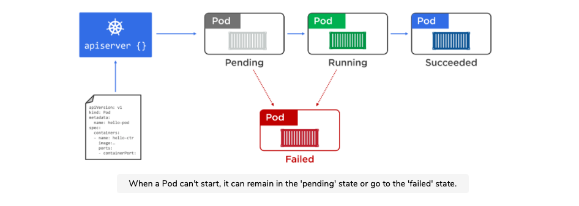Once everything is up and ready, the Pod enters the Running state.

Pods that are deployed via Pod manifest files are not managed by a controller that might add features like auto-scaling and self-healing. For this reason, we almost always deploy Pods via higher-level controllers such as Deployments and DaemonSets.

The key takeaway is that Pods are mortal. It is imperative we do not store states in Pods. It’s also why we should not rely on Pod IPs.

#### When to use Multi-Container Pods

The decision to make a multi-container Pod stems from the concept concerns as described in the Microservices section at the beginning.

Lets say we have two clear concerns:

1. Serving a web page
2. Making sure the content is up to date

Now we are faced with a question. Do we keep these two concerns in a single container or two separate container?

Microservice design patterns dictate that we should separate concerns, so we will have two containers. One for the web service, and another for the file sync service.

In cases like these where the two services have to have a shared memory or volume, it is acceptable to keep them in the same pod.

As seen above, the two containers will have a shared volume, which will store the web pages to be served.

### Packaging Apps for Kubernetes

For an application to run on a Kubernetes cluster, it needs to fulfil a few conditions:

1. Being packaged as a container
2. Being wrapped in a Pod
3. Being deployed via a declarative manifest file

Now going back to our previously defined Docker workflows, we will add the above steps to the process.

1. Write your app in the language of your choice
2. Build it into a Container Image
3. Store it in a registry

At this point, your app is containerized.

1. Define a Kubernetes Pod to run the containerized application
2. Deploy pod to cluster

### Deployments

It is possible to run a stand-alone Pod on a Kubernetes cluster, but the preferred model is to deploy all Pods via higher-level controllers. The most common controller is the Deployment. It offers scalability, self-healing, and rolling updates. You can define Deployments in YAML manifest files that specify things like which image to use and how many replicas to deploy.

Once everything is defined in the Deployment YAML manifest file, you POST it to the API server as the desired state of the application and let Kubernetes implement it.

Most of the time you’ll deploy Pods indirectly via a higher-level controllers, some of which are:

1. Deployments
2. DaemonSets
3. StatefulSets
4. Cron Jobs

Each has features and are wrappers around pods. For example, a Deployment is a higher-level Kubernetes object that wraps around a particular Pod and adds features such as scaling, zero-downtime updates, and versioned rollbacks.

Under the hood, Deployments, DaemonSets and StatefulSets all implement a controller and a watch loop that is constantly observing the cluster making sure that the current state matches the desired state.

#### Deployments (K8 Controller)

This is going to get confusing because the controller type is called Deployments as well, we will call the K8 Deployment controller K8Deployment from here on.

Up till now, we have only seen Pods being used, the problem with pods is that they do not self-heal, auto scale or allow for easy updates or rollbacks. As a result, we almost always deploy Pods via the K8Deployments controller.

A single K8Deployment Object can only manage a single Pod template. For example if you have an application with a Pod template for the Web Backend, and another Pod template for the Catalog Service, you will need two K8Deployment Objects.

Catalog

Catalog Replica

Catalog Replica

K8Deployment Controller/Object

Web Backend

Web Backend Replica

Web Backend Replica

K8Deployment Controller/Object

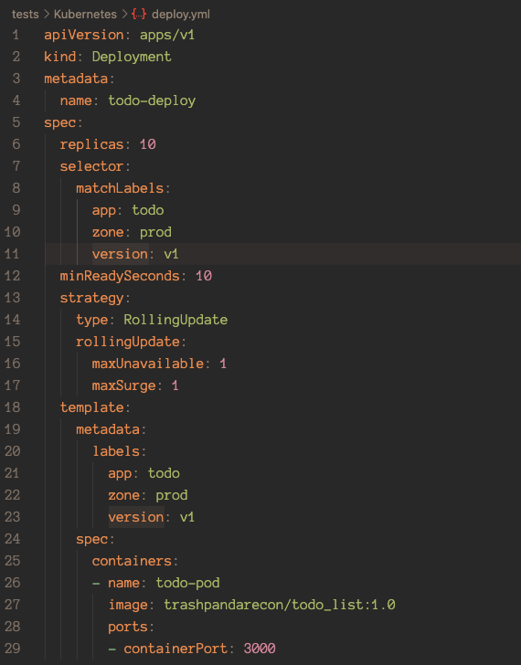

On the right is an example of a K8Deployment manifest.

Simply use Kubectl apply -f <filename> to deploy this file.

##### Rolling Updates

Rolling updates allow us to update our images with zero downtime to the application.

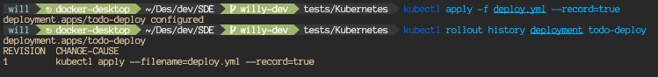The actual way to deploy the update is just to amend the original manifest file with the updated version number of the image and or any other changes you would like to make, then use the kubectl apply -f <deploy filename> --record=true. --record=true will record the update in the object’s history.

This may be a reason why you would use the record flag.

We can use the kubectl rollout command to roll back the application to REVISION 1 above using kubectl rollout undo deployment todo-deploy --to-revision=1.

When we roll back or roll up deployment versions, their ReplicaSets do not get deleted. The previous versions still exist which enables us to easily switch between revisions. This can be seen using kubectl get rs

Note that the operation of rolling between ReplicaSet configs is an imperative operations and will not change your YAML Manifest file. It is good practice to manually update the Manifest after doing a rollback with the config of the current active ReplicaSet configuration.

#### Service

Pods are unreliable, this statement is a result of a lot of technical details like how scaling pods cause a lot of IP churn, etc. As a result, Kubernetes has Service objects. Each Service Object has its own stable IP address, its own stable DNS name and its own stable port.

##### Internal

If we do a simulation, assuming that we have a microservices app with a bunch of Pods performing video rendering. How will this work if other parts of the app that need to use the rendering service cannot rely on pods being there when they are required?

This is where Service come into play. Services provide reliable networking for a set of Pods.

The Kubernetes Service is providing a reliable name and IP and is load balancing requests to the two renderer Pods behind it.

Services are fully fledged objects in Kubernetes API, like Pods and Deployments, they have a front end that consists of a stable DNS name, IP address, and port. On the back end, they load balance across a dynamic set of Pods, as Pods are born and die, the Service sees this and updates itself accordingly while continuing to provide that stable endpoint for other pods to access the renderers.

##### External

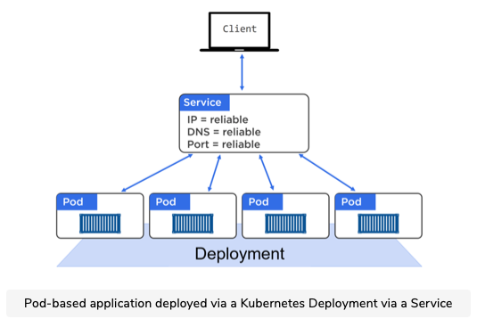It is not a good idea to talk directly to a Pod because that Pod could disappear at any point. Therefore we put a Service Object in front of a set of Pods as a medium for the client to interact through.

The service object maintains a list of healthy Pods throughout Pod rollbacks, scaling, and updating operations. These are all transparent.

##### Connecting Pods to Services

Services use labels and a label selector to know which set of Pods to load-balance traffic to. The service has a label selector that is a list of all the labels a Pod must possess in order for it to receive traffic from the Service.

The figure below shows a Service configured to send traffic to all pods on the cluster tagged with the following three labels.



* zone-prod
* env=be
* ver=1.3



An important note is that ALL labels have to match. A single different or missing label will result in it not being selected by the Service Object.

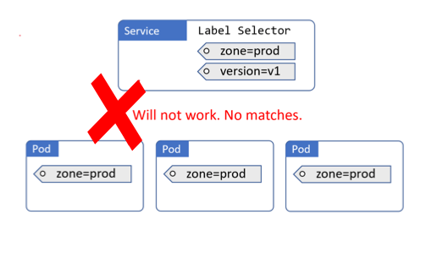

##### Service Types

* ClusterIP

This is the default option and gives the Service a stable IP address internally within the cluster. It does not make the Service available outside the cluster.

* NodePort

This builds on top of ClusterIP and adds a cluster-wide stable TCP or UDP port available outside the cluster on a stable port.

*** NodePort by design punches a gaping hole into Kubernetes security. It bypasses almost all Kubernetes Network Security and exposes an upper range of Ports not commonly used. This has the added effect of pissing off everyone using your service because the upper range of Ports may be blocked by Admins through firewalls. If you are building an External internet facing application. Look at Ingress instead.

* LoadBalancer

This builds on top of NodePort and integrates with cloud-based load-balancers.

* ExternalName

This is used to direct traffic to services that exist outside of the cluster.

##### Endpoints Objects

Every service gets its own Endpoints Object with the same name as the Service. The Endpoints Object holds a list of all the Pods the Service matches and is dynamically updated as matching Pods live and die. You can see Endpoints with the normal kubectl commands as well.

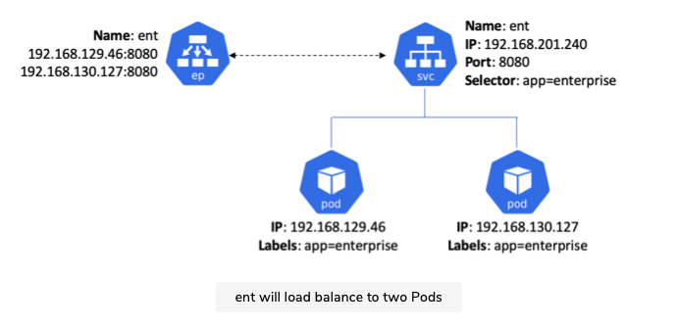The figure below shows a service named “ent”. It will load balance to two Pods. It also shows the Endpoints Object with the Ips of the two Pods that match the Service’s label selector

The kube-proxy on every node that sees the new Service and Endpoints objects will create IPVS (Linux IP Virtual Server) rules to redirect traffic to the Service’s ClusterIP to one of the Pods that match its label selector.

It is at this point that the Service is fully registered and ready to be discovered.

##### Diagram Description automatically generatedCluster DNS

As well as the various control plane and node components, every Kubernetes cluster has an internal DNS service that is vital to operations.

The cluster’s DNS service has a static IP address that is hard-coded into every Pod on the cluster, meaning all containers and Pods know how to find it. Every new Service Object is automatically registered with the cluster’s DNS so that all components in the cluster can find every service by name. There are other components registered with the cluster DNS, but for the sake of simplicity we will not go into them.

Services, not pods register with the Cluster DNS.

###### DNS as an analogy

The most common analogy for what DNS’s are is the phone book, but keeping with the theme of this guide, we will use a restaurant instead.

Service = Menu Item

Chef = Server

Waiter = DNS

Steak Chef, Yulia



Tom, two omelettes. Table 3

Omelette Chef, Tom

Two omelettes please.



Waiter

Pastry Chef, Alice

Waiter

The waiter knows which chef to ask for an omelette and where to find him at that moment in time. The DNS knows what the IP address of the requested Service is and which node to find them in.

##### Service Registration Summary

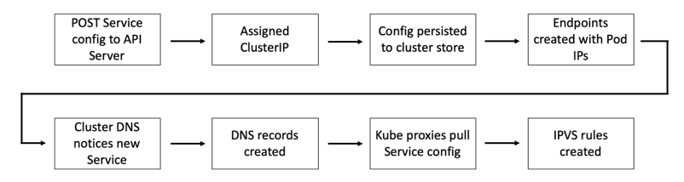To summarize Service Objects in Docker, here is a big picture overview of how it is created.

##### Service Discovery

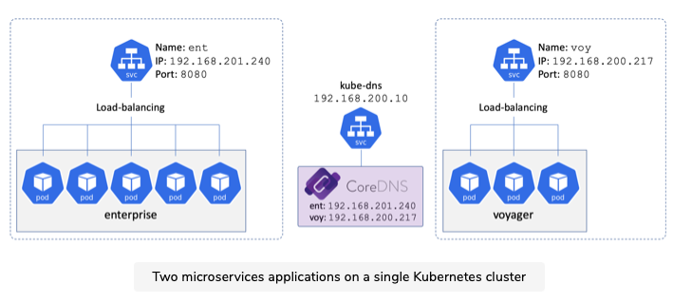Lets assume we have two microservices on a single cluster - enterprise and voyager. Both are registered according to the figure below.

For service discovery to happen, each microservice needs to know two things:

1. The name of the remote microservice they want to connect to
2. How to convert that name into an IP Address

Kubernetes automatically hardcodes a nameserver mapping in every container by adding it to their /etc/resolv.conf file. As well as any search domains that should be appended to unqualified names.

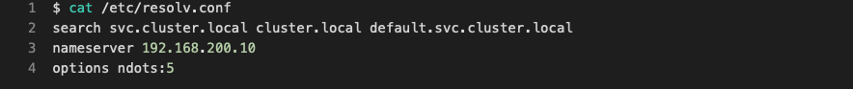Note: An “Unqualified name” is a short name such as ent. Appending a search domain converts an unqualified name into a fully qualified domain name (FQDN) such as ent.svc.cluster.local .

Nameserver being the ip address of the Cluster DNS.

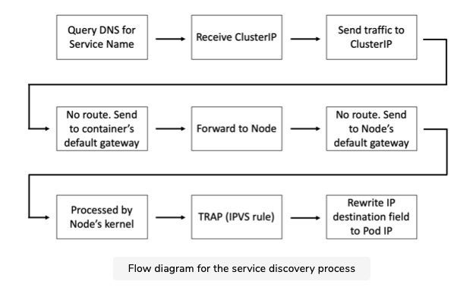For the sake of sanity, we will not delve deep into exactly how the traffic gets routed. Instead, we will just look at this flow diagram of the Service Discovery process.

##### A Production Use Case

This is all fine and interesting, but how does this actually bring tangible benefits to a business/application? Let’s take a look at a real world use case for this, updating applications with immediate no downtime rollbacks.

Updating applications is a fact of life, to achieve true no downtime updates and or rollbacks, we could use the K8Deployment type, but it does not provide true no downtime updates, it slowly replaces current old pods with new pods. One thing we could do is to take advantage of the Service label selector and its constant watch loop.

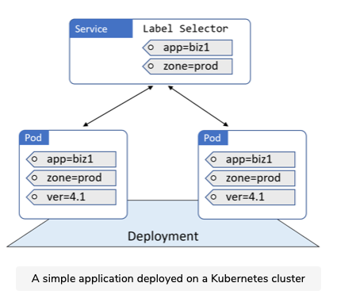Imagine that you have this setup below.

Now, assume you need to push a new version without causing any downtime or overlap. To do this, you can add Pods running the new version of the app, at which point the Service will load balance across both versions.

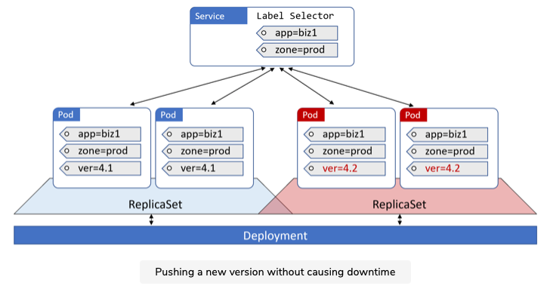

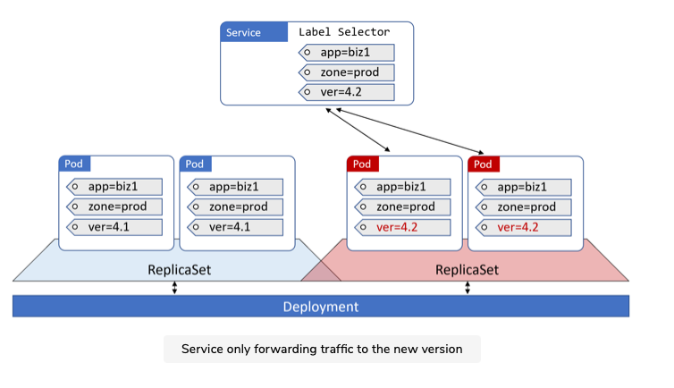Once you are happy with the updated version, you can force ALL traffic to use the newer version by simply updating the Service’s label selector to include version=4.2. Suddenly the old version no longer match and the Service sends all traffic to the new version.

Assuming we have two K8Deployments going on here, one for the current version and one for the previous version. The previous version will not disappear, it sits in the cluster waiting.

Now, why in the world could you possibly want old version Pods just sitting in your cluster being useless? The answer is simple, imagine there is a fatal error in the updated Pods that causes it to crash constantly on users. Imagine you are in charge of Amazon’s commercial sales site, any downtime causing inconvenience to customers is catastrophic to your reputation and every second the site is down will literally cost millions of dollars. The moment we are made aware of the error, all we have to do is change the label selector of the Service Object to 4.1 and business will proceed as usual within seconds, albeit at reduced capacity. While the dev team gets fired, you get praised for saving operations and literal millions for the company.

Obviously this only applies in extremely high stakes scenarios where seconds will bleed an inordinate amount of money from the business. Otherwise it is perfectly fine and preferable to use a single K8Deployment.

#### Ingress

#### Namespaces

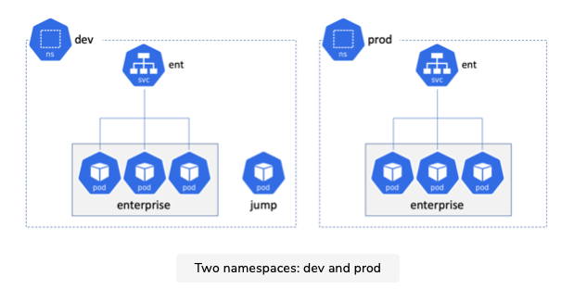If you don’t know what namespaces are, it is similar to the idea of context. Lets take a look at the figure below where we have two namespaces, dev and prod.

Notice how they both have an ent Service? With namespaces, we can have identical names but in different contexts.

Pods can access the ent services in either namespace in a couple of ways, you can directly use the IP of the services, or use domain names. The most reliable way of using domain names to access the services is by using the FQDN. For example, ent.prod.svc.cluster.local:8080 to access the prod ent service. You can also just access it via ent:8080, but it will depend on how the /etc/resolv.conf file was set up, the container will automatically append either prod.svc.cluster.local or ent.svc.cluster.local to the ent name.ß

### Working with Kubernetes

There are many ways to get a Kubernetes Cluster, the easiest way is to use a Hosted Kubernetes cluster, they are the closest you will get to zero effort production grade Kubernetes. Google Kubernetes Engine (GKE) lets you deploy a production-grade Kubernetes cluster with just a few clicks. Other clouds offer similar services as well.

* AWS: Elastic Kubernetes Service
* Azure: Azure Kubernetes Service
* Linode: Linode Kubernetes Engine
* DigitalOcean: DigitalOcean Kubernetes
* IBM Cloud: IBM Cloud Kubernetes Service
* Google Cloud Platform: Google Kubernetes Engine

For the purpose of experience with the software, we will use Docker Desktop. Keep in mind that there are quite literally over a hundred ways to get a Kubernetes Cluster.

#### Docker Desktop

Docker Desktop lets us get a local development cluster on our Mac/Windows machine. With a few easy steps, we can get a single-node Kubernetes cluster that we can develop and test with.

It works by creating a VM on your laptop and starting a single-node Kubernetes cluster inside that VM. It also configures a Kubectl client with context that allows it to talk to the cluster in the VM. There is also a simple GUI that lets us perform basic operations such as switching between all of our Kubectl contexts.

Docker Desktop can be downloaded from the Docker website, a login may be required but rest assured that the account is free and so is the product. If you already have Docker Desktop installed, the option to enable Kubernetes is under Preferences.

The commands we will go through should work on other Kubernetes cluster services as well.

#### Kubectl

Kubectl is the main Kubernetes CLI Tool and is what we will use for day to day Kubernetes management.

At a high level, Kubectl converts user-friendly commands into JSON payloads required by the API server in Master. It uses a config file to know which cluster and API server endpoint to POST commands to.

The kubectl config file is called config and lives in the $HOME/.kube/ directory.code config

As seen above, it contains definitions for:

* Clusters
* User Credentials
* Contexts

#### Pod Manifest File

Manifest Files are excellent sources of documentation. By keeping documentation for the basic functions and requirements of an application in the manifest file, new members can immediately see the configuration for the app and what it requires.

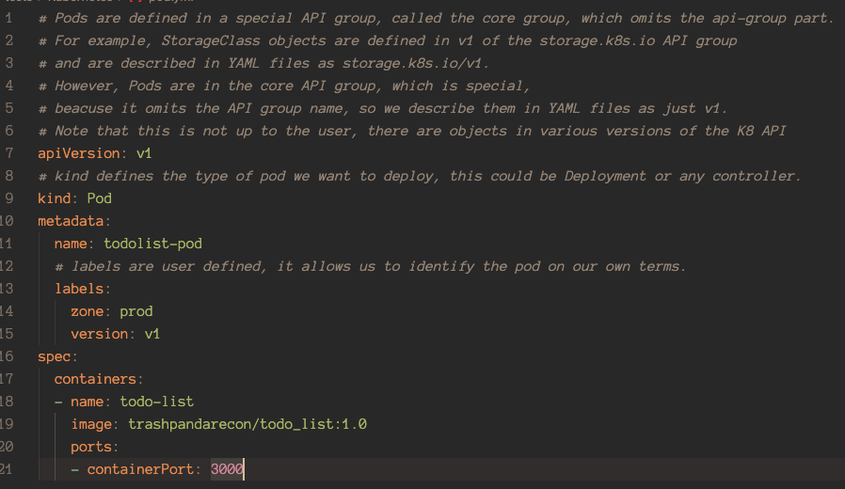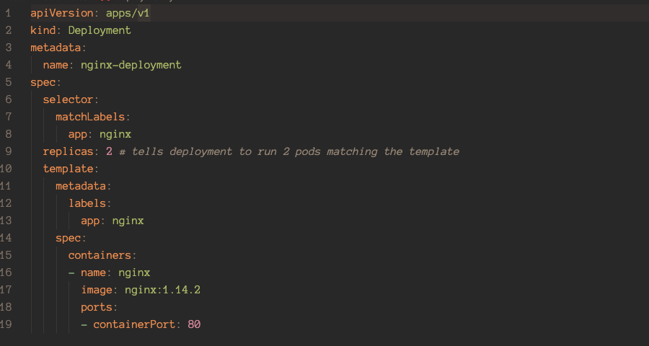Examples of Manifest Files, for a list of all possible parameters, refer to Kubernetes Documentation.

#### POSTing a Manifest File

As an exercise, we will deploy a pod which contains a todo-list app. The Manifest file should be in the test/Kubernetes folder. An example of what the file should look like is below

To POST a manifest file, simply use kubectl apply -f <filename>

To get a list of all pods, we can use the kubectl get pods command.

We can see a detailed description of the pod via the kubectl describe command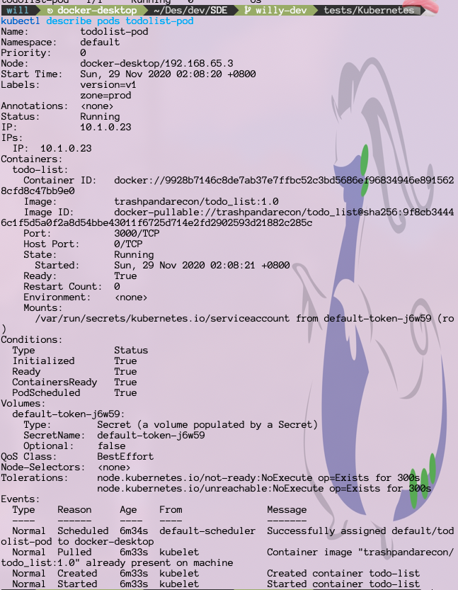

#### Interacting with Pods

K8s has a similar mechanic to Docker when it comes to interacting with running pods named kubectl exec

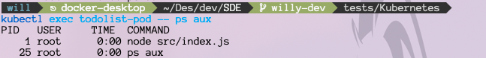You can run a single command like this.

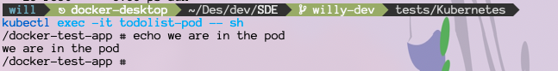Or run an interactive shell like this.